1. **Agenda**:
   1. Let’s see the role of token in AUTHN and AUTHZ flows.
2. 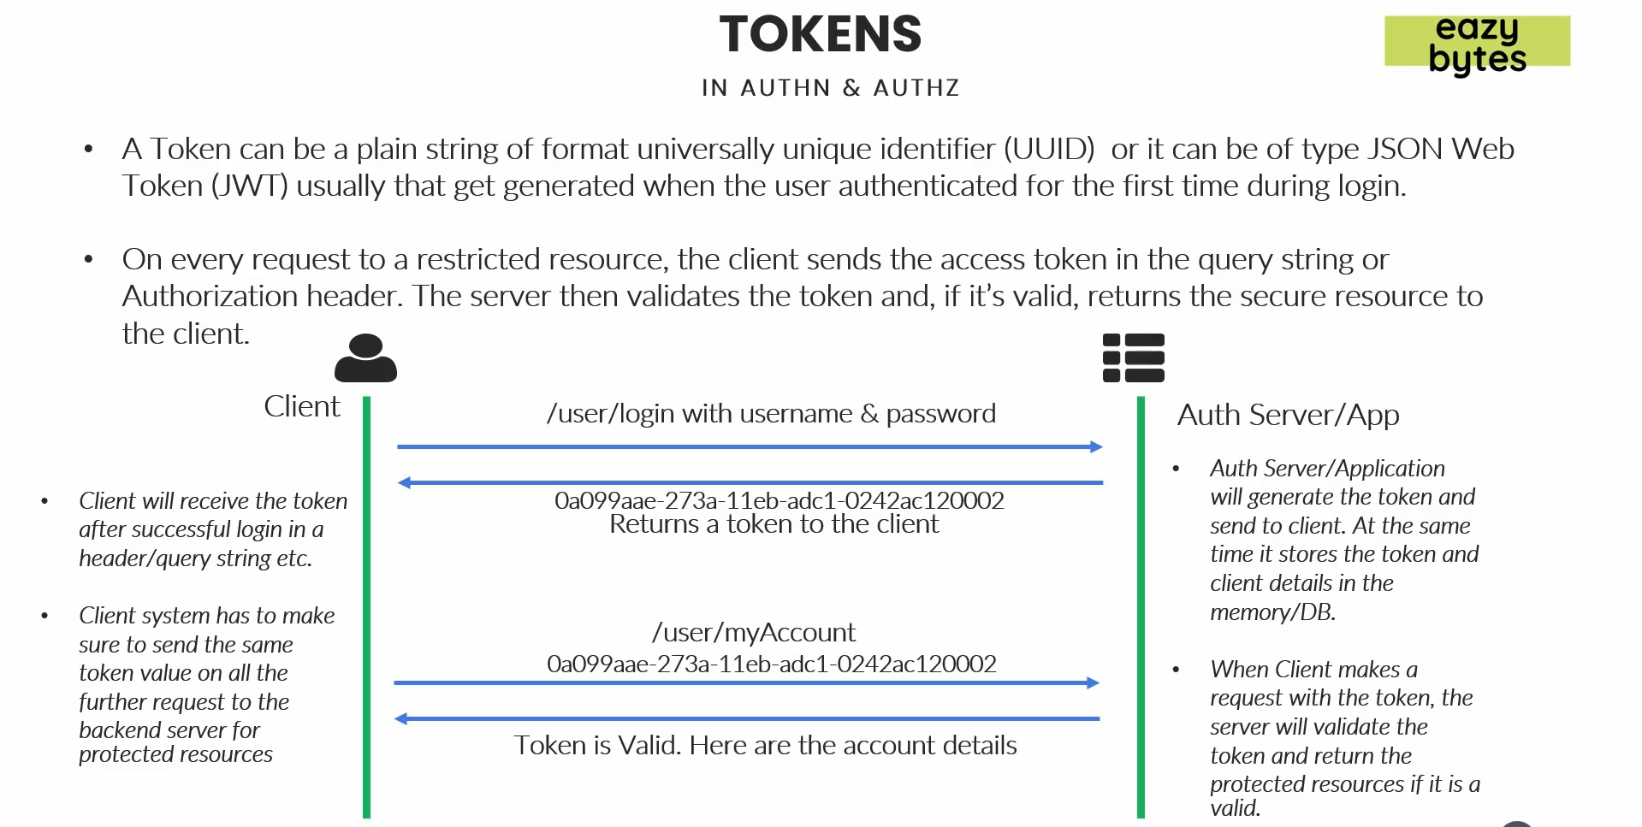
3. Many frameworks including spring security uses token based authentication and authorization which is an efficient way of validating user details which we received from the client side.
4. **Token format**:
   1. String of format UUID.
   2. or industry standard token such as JWT.
5. Such token is generated when the very first a user is authenticated.  
   In each subsequent request, the token is passed along with the request when accessing a protected resource for validation.
6. **Why token?**
   1. We don’t want to share credentials again and again.
7. How token is given to the client the very first time when a user is authenticated successfully?
   1. Via header or
   2. Through Query String in the response.
8. Where the token is stored by the client?
   1. In a local storage.